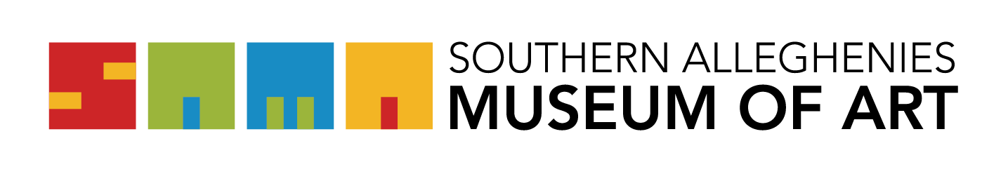
Artists of the 21st Century: Student Art Exhibition 2022

Registration Form
Please e-mail form to SAMA Loretto at loretto@sama-art.org no later than December 17, 2021.
NO LAST MINUTE SUBSTITUTIONS WILL BE ACCEPTED. Please make sure all information is correct before submitting this form.

PLEASE PRINT OR TYPE:
School: _____________________________________________
School District: _______________________________________
Art Teacher: __________________________________________
Check one: o Primary o Elementary o Jr. High o Sr. High

STUDENT NAME GRADE MEDIUM

GROUP PROJECTS (MAXIMUM 3)
NAMES GRADES MEDIUM

