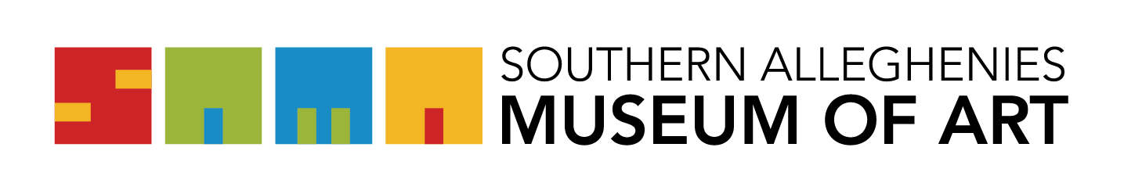
Artists of the 21st Century: Student Art Exhibition 2026

Registration Form
Please e-mail form to SAMA at kmiller@sama-art.org no later than December 19, 2025.
Please do not make last-minute changes otherwise there is no guarantee of correct labeling. Make sure all information and spelling of names are correct before submitting this form.
PLEASE PRINT OR TYPE:
School: _____________________________________________
School District: _______________________________________
Art Teacher: __________________________________________
Check one: Pre-K Elementary Jr. High Sr. High

STUDENT NAME | GRADE | 2D OR 3D | MEDIA: identify acrylic, oil, tempera, pastel, ceramic, photograph, etc. (use mixed media if more than one)

GROUP PROJECTS (MAXIMUM 3)
STUDENT NAMES | GRADES | 2D OR 3D | MEDIA

TEACHER PROJECTS (MAXIMUM 1)
TEACHER NAME | GRADE | SIZE | MEDIA | INSURANCE VALUE

