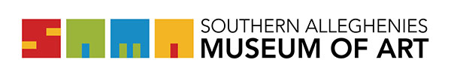

Residency Invoice  Artist in Residence Program | Southern Alleghenies Museum of Art  P.O. Box 9, Loretto, PA 15940  p: 724-238-6015 / f: 724-238-6281  kmiller@sama-art.org

Please complete ALL fields below and return to:

SAMA Loretto
P.O. Box 9
Loretto, PA 15940

Email: shampton@sama-art.org

Name of Artist: ________________________________________________________________________
Phone Number: ________________________________ Email: _________________________________
Address: _____________________________________________________________________________
City: _________________________________ State: _____________ Full Zip: ____________________
Site Coordinator(s)/Teacher(s): ___________________________________________________________
Host Site/School: ______________________________________________________________________
Artist Residency:
Date Rate: _____________________________________________________________________
Residency Dates: ________________________________________________________________
Total Number of Days: ___________________________________________________________
Mileage (if applicable: over 50 miles one way): __________________ X $0.56/mile = $________

This is an invoice for payment for residency activities. All residency evaluations must be completed by the artist within a week of completing the residence. You will find the evaluation link at www.sama-art.org/forms-applications.
An invoice for an Artist Residency may be submitted to SAMA after the first 10-days of a 20-day residency. A second invoice will need be submitted for the final 10-days of the 20-day residency.
Payments will not be granted for residency days not approved by SAMA.
Artist Evaluations must be completed before any payment is made.

