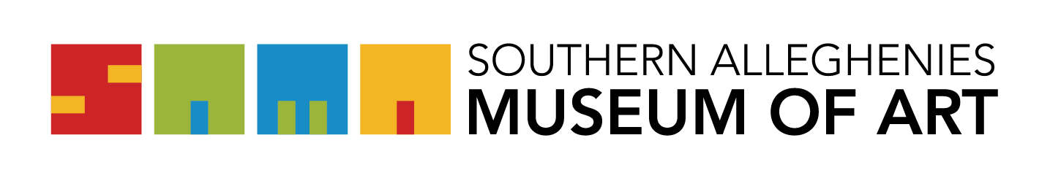
Artists of the 21st Century: Student Art Exhibition 2026

Letter of Intent/Acknowledgement Form
Please print, legibly.

I, ____________________________________________________, am submitting this letter of intent to participate in the Artists of the 21st Century: Student Art Exhibition.

SCHOOL____________________________________________________________
SCHOOL DISTRICT:___________________________________________________

I acknowledge that I have read and agree to abide by the guidelines as they pertain to the Student Art Exhibition and SAMA regulations. I understand if the guidelines are not met for any object, that object will be excluded from the exhibition: initials:__________

Check the Museum your school will be exhibiting at:

____ SAMA Ligonier ____SAMA Johnstown ____ SAMA Bedford ____ SAMA Altoona

Agreement of Responsibility
The Southern Alleghenies Museum of Art (SAMA) will take the appropriate measures to ensure the safety of the artwork during installation and while on display. Any loss OR damage to the artwork is NOT the financial responsibility of the Museum.

I verify that I have read and understand the above statement:

Signature:_______________________________________________________
Date: ________________

This form is to be mailed/emailed to: SAMA Ligonier One Boucher Lane & 711 South Ligonier PA 15658 or emailed to kmiller@sama-art.org.

ALL LETTERS MUST BE RECEIVED BY FRIDAY, NOVEMBER 21, 2025

