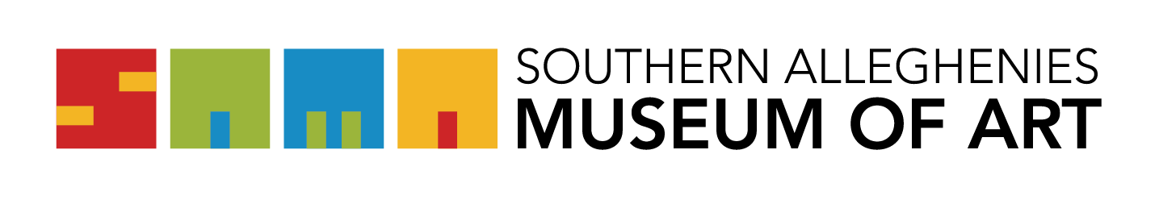
Artists of the 21st Century: Student Art Exhibition 2022
GUIDELINES and Regulations:
Please read the following guidelines carefully.
- The letter of intent/acknowledgement form to participate must be received by Friday, November 19, 2021. Send your letters via email to Southern Alleghenies Museum of Art at loretto@sama-art.org.
- The registration form deadline is Friday, December 17, 2021. Drop-off and pick-up dates are at the end of this note. Please email your registration form to SAMA Loretto at loretto@sama-art.org
If all requirements are not met, the artwork in question will be excluded from the exhibition.
- All two-dimensional pieces must be matted, framed, and ready to hang with screw eyes and proper hanging wire. Pieces not ready to hang will be excluded from the exhibition. NOTE: A screw eye/D-ring may be used on each side of the frame, and wire should be attached 1/3 of the way down.
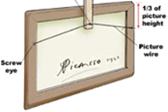
- Each district, not a school within a district, is limited to 25 TOTAL individual pieces per DISTRICT. In addition, two large-scale group projects may be submitted. Again, a group project consists of one collective object, not individual artworks grouped together.
- NOTE: Please contact SAMA’s Education Coordinator via e-mail at loretto@sama-art.org with size dimensions of group projects. The museum reserves the right to reject any artwork that is too large to be properly displayed within the limited space of our galleries.
- Each piece must be labeled on the back with the student’s name, grade, school, medium of the piece, and art teacher (labels will not be provided by the museum; however, teachers will be reminded by e-mail of requirements and important dates).

- If the work is dropped off at the Southern Alleghenies Museum of Art at Altoona or Johnstown to be shipped by the Museum to Loretto, the work must be packaged for shipping. Each package must be labeled with the student’s name, grade, school, school district, medium, and art teacher’s name.
I verify that I have ready and understand the above statements:

_________________________________________________ Date:________________

IMPORTANT DATES
Artwork Drop-off:
Altoona: January 12, 13, & 14 2022
Johnstown: Call SAMA Loretto @ 814-472-3920 to make arrangements
Loretto: January 12, 13, & 14 2022
Ligonier Valley: February 2, 3, & 4, 2022

Artwork Pick-up:
Altoona: January 12, 13, & 14 2022
Johnstown: Call SAMA Loretto @ 814-472-3922 to make arrangements
Loretto: April 20, 21, & 22, 2022
Ligonier Valley: April 20, 21, & 22, 2022

EXHIBITION DATES

SAMA Ligonier - February 11 - April 17, 2022
SAMA Loretto - January 28, - April 3, 2022

