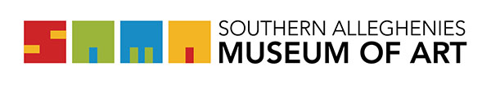

Artist Information Update Form  Artist in Residence Program | Southern Alleghenies Museum of Art  P.O. Box 9, Loretto, PA 15940  p: 724-238-6015 / f: 724-238-6281  kmiller@sama-art.org

Please complete ALL fields below and return to:

SAMA Loretto
P.O. Box 9
Loretto, PA 15940

Email: kmiler@sama-art.org

Name: _________________________________________________________________________________ _

Address: ________________________________________________________________________________

City: __________________________State: _________________***Full Zip: _________________________ _

Phone: _______________________________________ Email: __________________________________ ___

Website: _________________________________________________________________________________

Facebook:________________________________________________________________________________

Instagram:________________________________________________________________________________

Twitter:__________________________________________________________________________________

Other:___________________________________________________________________________________

Minimum Fee per Day: $________________

Attachments
- Resume
- References
- JPEGs of Artwork or videos or links
- Jpeg of Artist for Directory

