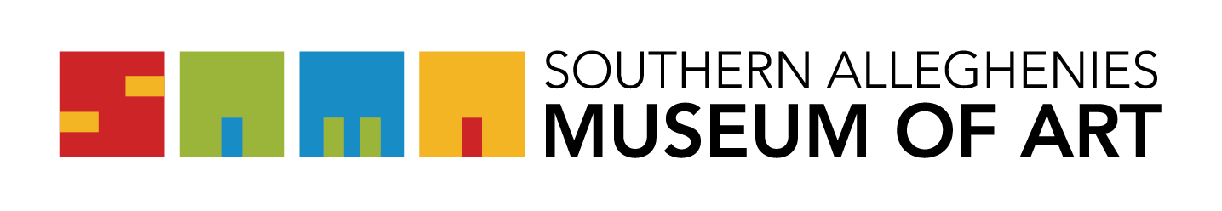

Photograph and Media Release Form

We appreciate the opportunity to photograph/videotape your participation in activities at SAMA. By documenting the visitation and creative arts process from beginning to end and capturing the energy, enthusiasm, focus, and pride reflected in our exhibitions and programs we are better able to share the value and importance of the arts.

The photos and images of you and/or your artwork may be displayed and included in online and hardcopy publications, public relations materials, and social and broadcast media produced and distributed by the Southern Alleghenies Museum of Art.

Please complete the information below and return this form to a SAMA staff member.

PLEASE CHECK:

I do give my permission to the Southern Alleghenies Museum of Art to use the photograph(s)/video(s) of myself and/or images of my work for the above-stated purposes. I understand that there is no compensation of any kind for any use of my likeness or images of artwork.

Name: __________________________________________

_______________________________________________________ _____________________
Signature Date

